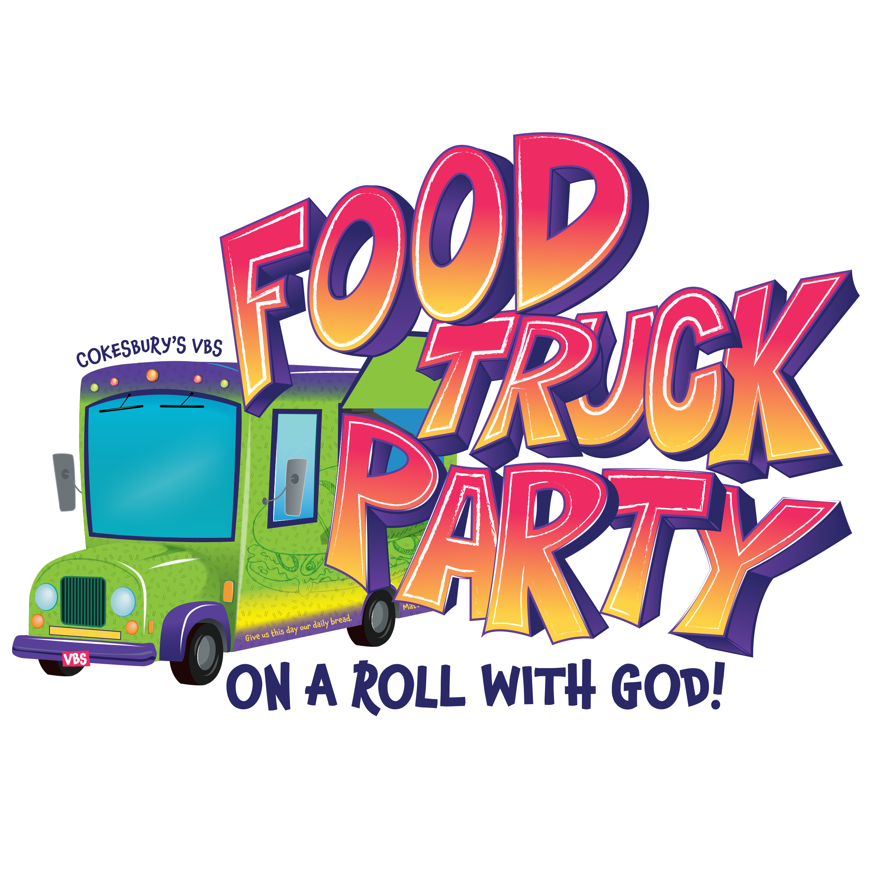
FOOD TRUCK PARTY: On a Roll with God!
When: July 18th-21st*, 6-8pm | Where: Laurel UMC- 307 W 4th St
Who: Preschool (3 years old/potty trained) - 5th Graders
Youth volunteers in grades 6th-12th welcome!

Student name: Birth Date:
Preferred nickname:
Grade student will be attending this fall - Please Circle One: Pre K 1 2 3 4 5

Please list any siblings that will also be attending: (Name, age)

Parent/Guardian Name:
E-mail Address:
Mailing Address:
Phone Numbers Home Cell
Emergency Contact: Phone:
Allergies/Medical Information/Other:

Person/s Responsible for Pick-up
Is there a specific friend your child would like to be with:
Thursday evening is Family Night at VBS. We’ll be sharing a meal together and invite families to participate in the evening’s activities or sit back and relax while the kids carry on. Times may be adjusted, TBA later.
HOW MANY ATTENDING FAMILY NIGHT @ VBS (Thursday, July 21)?

Other Information (church use only) Are parents helping with Food Truck Party VBS? Y / N If yes, where?

Child’s Group (circle one): Cupcake Crew Muffin Musketeers Kabob Crew Pizza Pals

* * * * * * * * * * * * * * * * * * * * * * * * * * * * * * * * * * * * * * * * * * * * * * * * * * * * * * * * * * * * * * * * * * * * * * *
Please return to the church office: Laurel United Methodist Church 307 West 4th Street. P.O. Box 1055 / Laurel, MT 59044 OR register online at www.umclaurelkidtalk.weebly.com
The kids will need to check in daily to receive their nametags. We will open and close each day in the sanctuary. Please dress your child/ren comfortably. Questions: Contact Becca at 672-0207/628-6362 or becca.lumc@gmail.com
Colors of the Day: Monday-Red/Pink | Tuesday-Green | Wednesday-Blue | Thursday-Purple

